**Configuration environment for instant-ngp\***

* Visual studio 2019 community with C++
* CUDA 11.6.2
* Optix
* Git
* Clone original code from <https://github.com/NVlabs/instant-ngp>

**Modify transformation.json file to be compatible with drone 3d restructuring project\***

* Adding <https://github.com/nickponline/dd-nerf-dataset>
* Understanding code
* Figure out requirements
* Customize camera parameter etc.
* Add more thing to make different
* Test

Using OpenCV integrated stitcher to carry out 2D image stitching

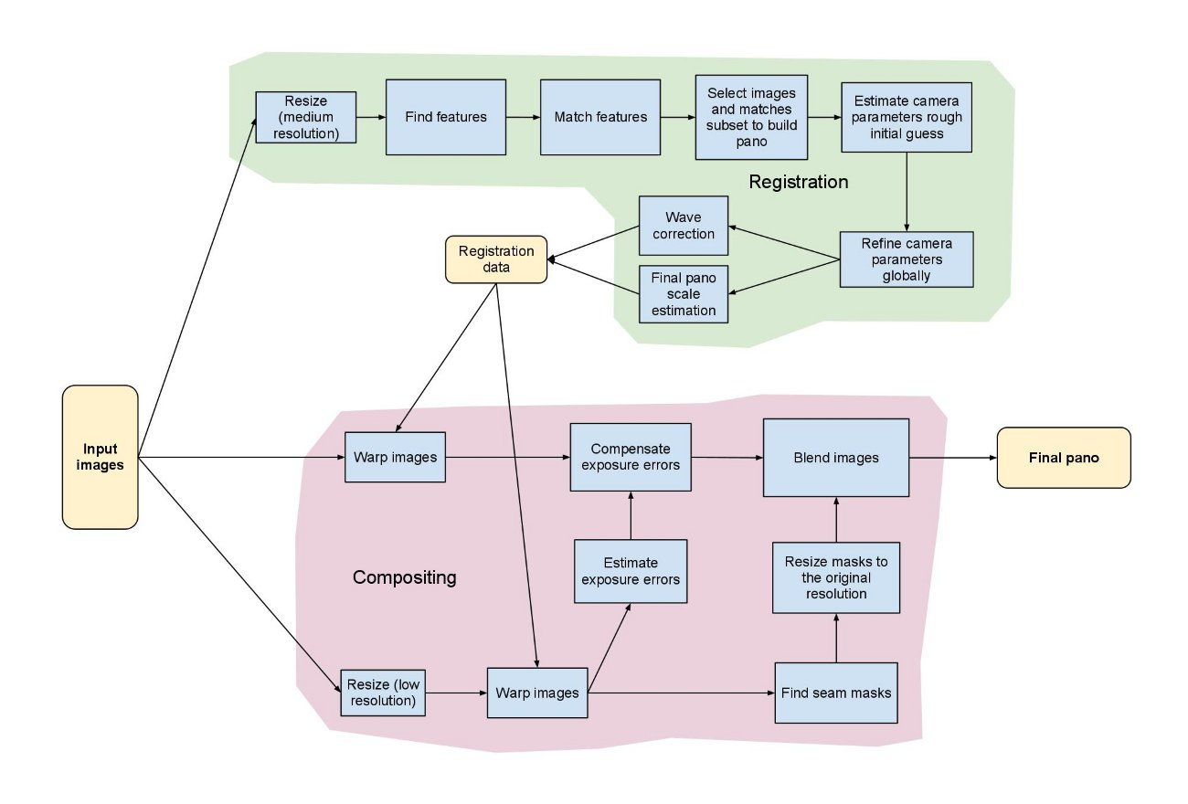

* Take 2 examples of images (indoor & outdoor)
* Learn stitcher in OpenCV
* Test

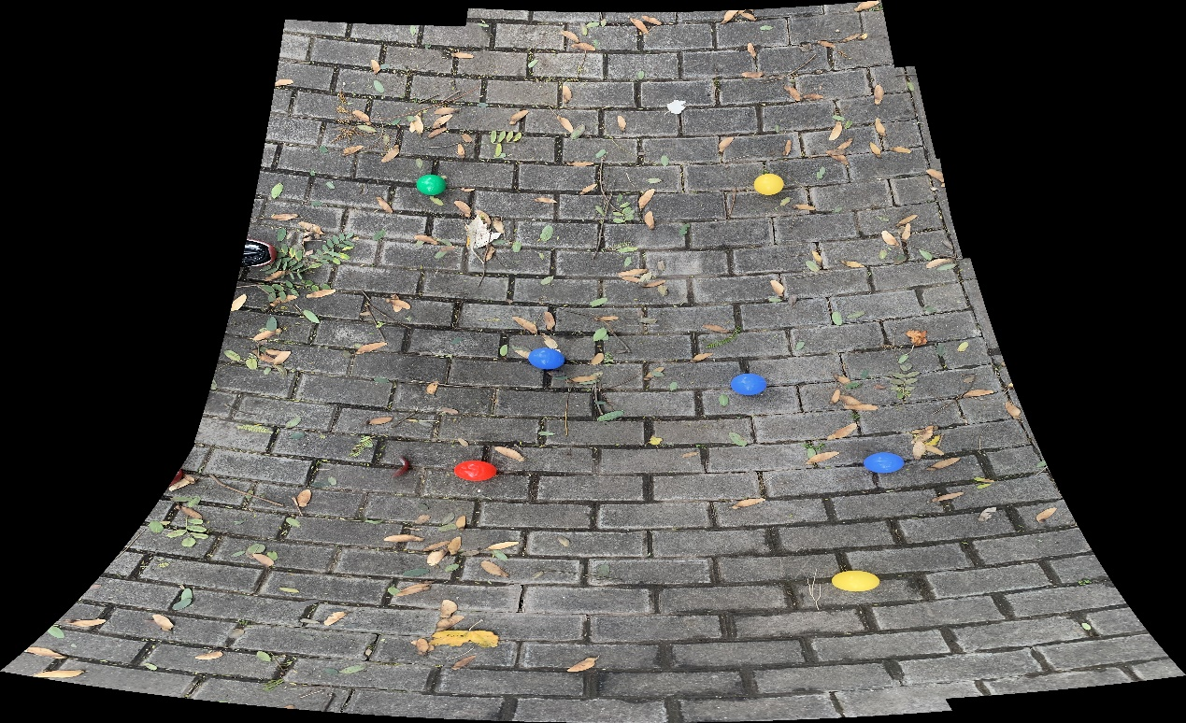

Output 1. with huge distortion

I got this from **OpenCV integrated stitcher**. Output 1 contains all possible elements and details in the 9 pictures, but it generated with a huge distortion. Some possible reasons are the altitude, parallel angle or position of my phone were changing. Also, maybe due to the stitcher mechanism, the top half of the stitched image is flatter, but the bottom isn’t. The order of processing images?

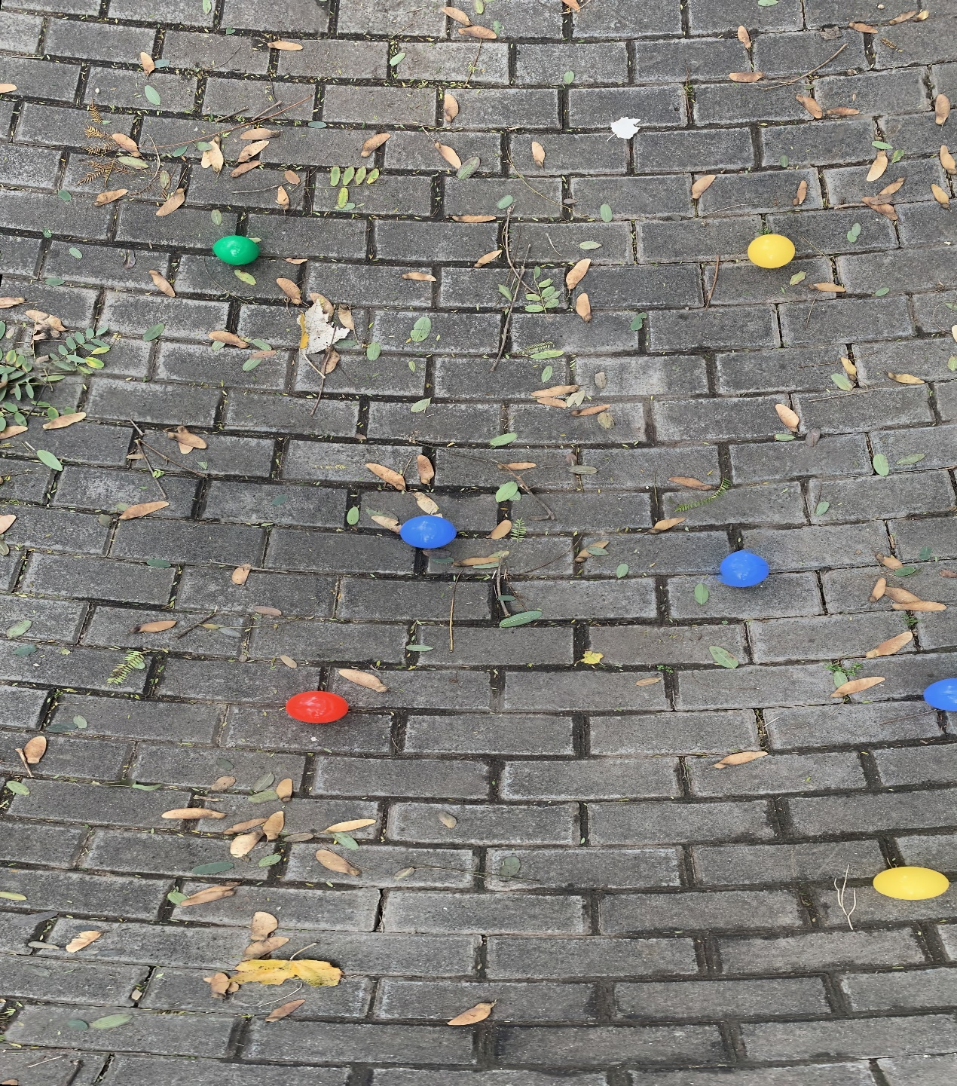

Output 2 with less distortion

Using a ***‘stitching’* library** in python, I got a result like this. There is loss of details around but better central distortion. May requires more lateral overlap when the drone flies around.

Another method to stitch is to use **traditional 2-images-stitching** (code already done at payload class) then loop over every images. For example, we have 1,2,3,4,5 images. I will stitch 12,23,34,45, and 12-23, 23-34, 34-45 etc…

I am not too optimistic about this approach since images have to be strictly sorted in folders and when reading as a list, and the elapsed time can be very long, also the system load would be high.

Difficulty: The image generated after image stitching is not regular, and it cannot be directly stitched with the next image. Main Error: array shape different.

Solution: Cut the images into the maximum optimum same size to do further stitching, but this kind of method may reduce the level of detail. Another viable solution will be using mask.

Features detector: SIFT by default, will be using ORB an so on in the future

Mathcer:

cv.detail_AffineBestOf2NearestMatcher()

cv.detail_BestOf2NearestMatcher()

detail_BestOf2NearestRangeMatcher(range_width)



Those features matched are too much concentrated in one area of the image. It is clear that the two images have many matching feature points, but these methods do not take into account other regions of the whole image. But it is also possible that I did not use a confidence threshold, resulting in too many matched features.

BF(Brute-Force) Matcher:

This matching method is simpler and only requires finding the next set of feature values after calculating the distance



Image cropping:

After one image stitching, the resulting image will generally become irregular(such as polygon), which will affect the next image stitching operations like warping. I found a way to solve this type of problem:

First predict the size of the panorama, which can be determined by the overlap rate, and single image size. Define the size of the window based on the size of the panorama and fill it with black.

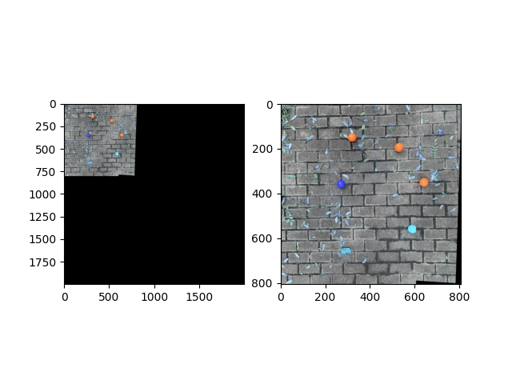

We were able to get an image similar to the one on the left, making sure that the stitched image was large enough to be placed in the window. Next, use def remove_the_blackborder(image) to crop the image(on the right). However, since the cropping of the image is based on the outer maximum rectangle, a small amount of black is retained at the edges. I didn't think they would have a huge impact on the final result, but the final panorama was not satisfactory.

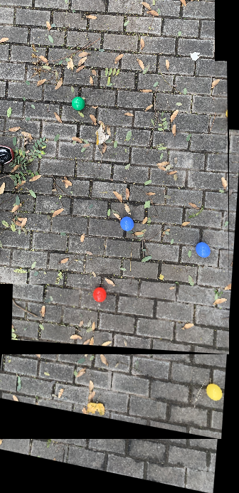

For a better panorama, I decided to use the largest inferior rectangle for the cropping. After searching, the method to calculate the internal maximum rectangle is so complicated that I decided to use the package directly.

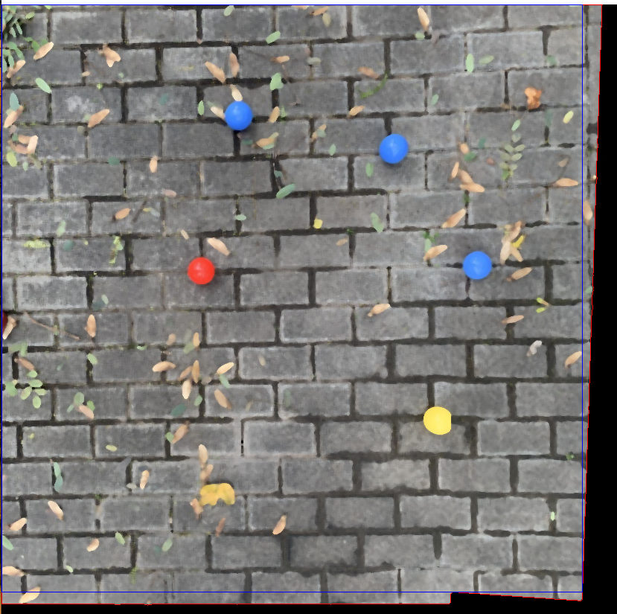

The blue rectangle in the image is the ROI, I need to crop that.

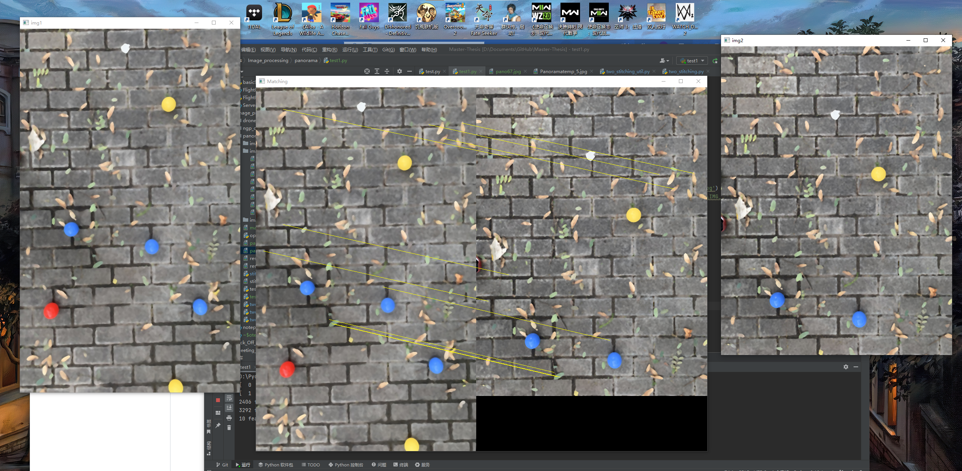

Step1, images[0, 1, 2, 3]

